**f = 100**

**t2=0:0.00005:0.05;**

**pi = 3.14156**

**x2=sin (2 * pi * f * t2);**

**subplot (2, 2, 1)**

**plot (t2,x2);**

**xlabel('Time');**

**ylabel('Amplitude');**

**title ("sin (200pi*t)");**

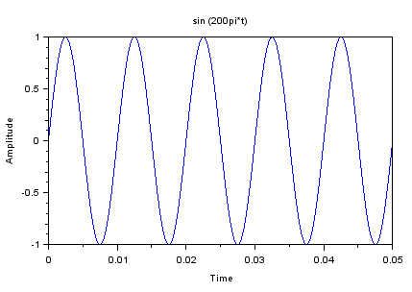

**x2=sin ((2 * pi * f * t2) + (pi / 6));**

**subplot (2, 2, 2)**

**plot (t2,x2);**

**xlabel('Time');**

**ylabel('Amplitude');**

**title ("sin (200pi*t + pi/6)");**

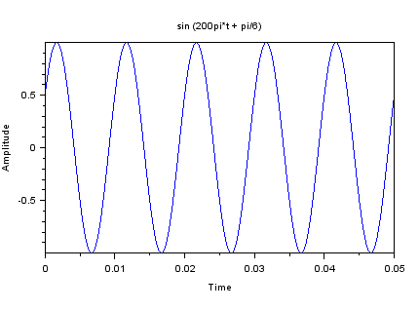

**x2=sin ((2 * pi * f * t2) - (pi / 6));**

**subplot (2, 2, 3)**

**plot (t2,x2);**

**xlabel('Time');**

**ylabel('Amplitude');**

**title ("sin (200pi*t - pi/6)");**

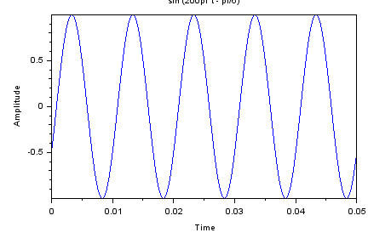

**f = 100**

**t2=0:0.00005:0.05;**

**pi = 3.14156**

**x2=cos (2 * pi * f * t2);**

**subplot (2, 2, 1)**

**plot (t2,x2);**

**xlabel('Time');**

**ylabel('Amplitude');**

**title ("cos (200pi*t)");**

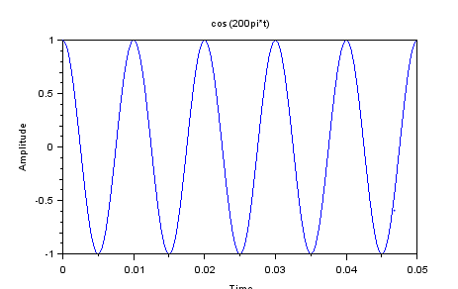

**x2=cos ((2 * pi * f * t2) + (pi / 6));**

**subplot (2, 2, 2)**

**plot (t2,x2);**

**xlabel('Time');**

**ylabel('Amplitude');**

**title ("cos (200pi*t + pi/6)");**

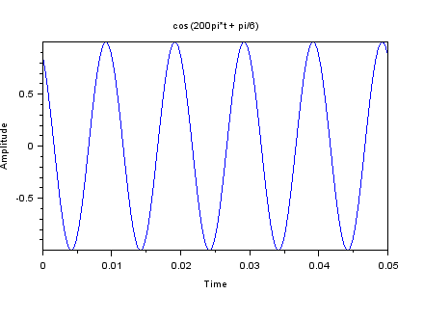

**x2=cos ((2 * pi * f * t2) - (pi / 6));**

**subplot (2, 2, 3)**

**plot (t2,x2);**

**xlabel('Time');**

**ylabel('Amplitude');**

**title ("cos (200pi*t - pi/6)");**

